ANALYSIS OF NLP IN DIGITAL NOTE-TAKING APPLICATIONS
Natural Language Processing Assignment 1

Student Name: Malik Reshma Shafaat Husain
Roll Number: 30
UIN Number: 231A031
Class: BE (AI&DS)
Assigned NLP Application: Digital Note Taking

1. Introduction
Digital note-taking applications help users create, store, organize, search and summarize notes. Natural Language Processing (NLP) can make these tasks easier by identifying important information, summarizing long text, retrieving relevant notes, and processing different languages. This report tests a short note about food-waste management in India using Microsoft OneNote and Evernote. Notion was also opened during preliminary testing, but its AI feature displayed “Unavailable while offline”; therefore, the main output comparison focuses on the two tools for which concrete observations are available.

2. Test Design and Input Data (CO1 i-a)
The same English sample was entered into OneNote and Evernote to make the comparison as fair as possible. A separate Hindi sample was then tested in Evernote. The topic was selected because it includes Indian cultural contexts—festivals and weddings—and a practical safety issue.

2.1 English input
Topic: Food Waste Management in India
Restaurants and hotels often produce surplus food. NGOs and volunteers can collect safe surplus food and distribute it to people in need. Proper coordination reduces food waste and supports society. Festivals and weddings in India may generate large amounts of surplus food. Food safety must be checked before distribution.

2.2 Hindi input
भारत में त्योहारों और शादियों के दौरान बहुत सारा खाना बच जाता है। स्वयंसेवक और गैर-सरकारी संगठन सुरक्षित बचे हुए भोजन को जरूरतमंद लोगों तक पहुँचा सकते हैं। भोजन बाँटने से पहले उसकी गुणवत्ता और सुरक्षा की जाँच करना जरूरी है।

2.3 Prompts and search query
English summary prompt: “Summarize these notes in five bullet points. Preserve the original meaning and all important details.”
Hindi summary prompt: “इन नोट्स का सारांश पाँच बिंदुओं में लिखिए। मूल अर्थ और सभी महत्वपूर्ण जानकारियाँ बनाए रखें।”
Search query: “food safety”. An additional natural-language query was attempted: “Find the note containing information about food safety during surplus food distribution.”

3. Tool 1 — Microsoft OneNote (CO1 i-b)
The English food-waste sample was pasted into a OneNote page titled “ANALYSIS OF NLP IN DIGITAL NOTE-TAKING APPLICATIONS.” The note displayed the title and paragraph successfully. However, Copilot was not available in the account during the test, so an AI-generated summary could not be obtained. This confirms basic note entry and storage, but it does not measure the accuracy of OneNote’s AI summarization.
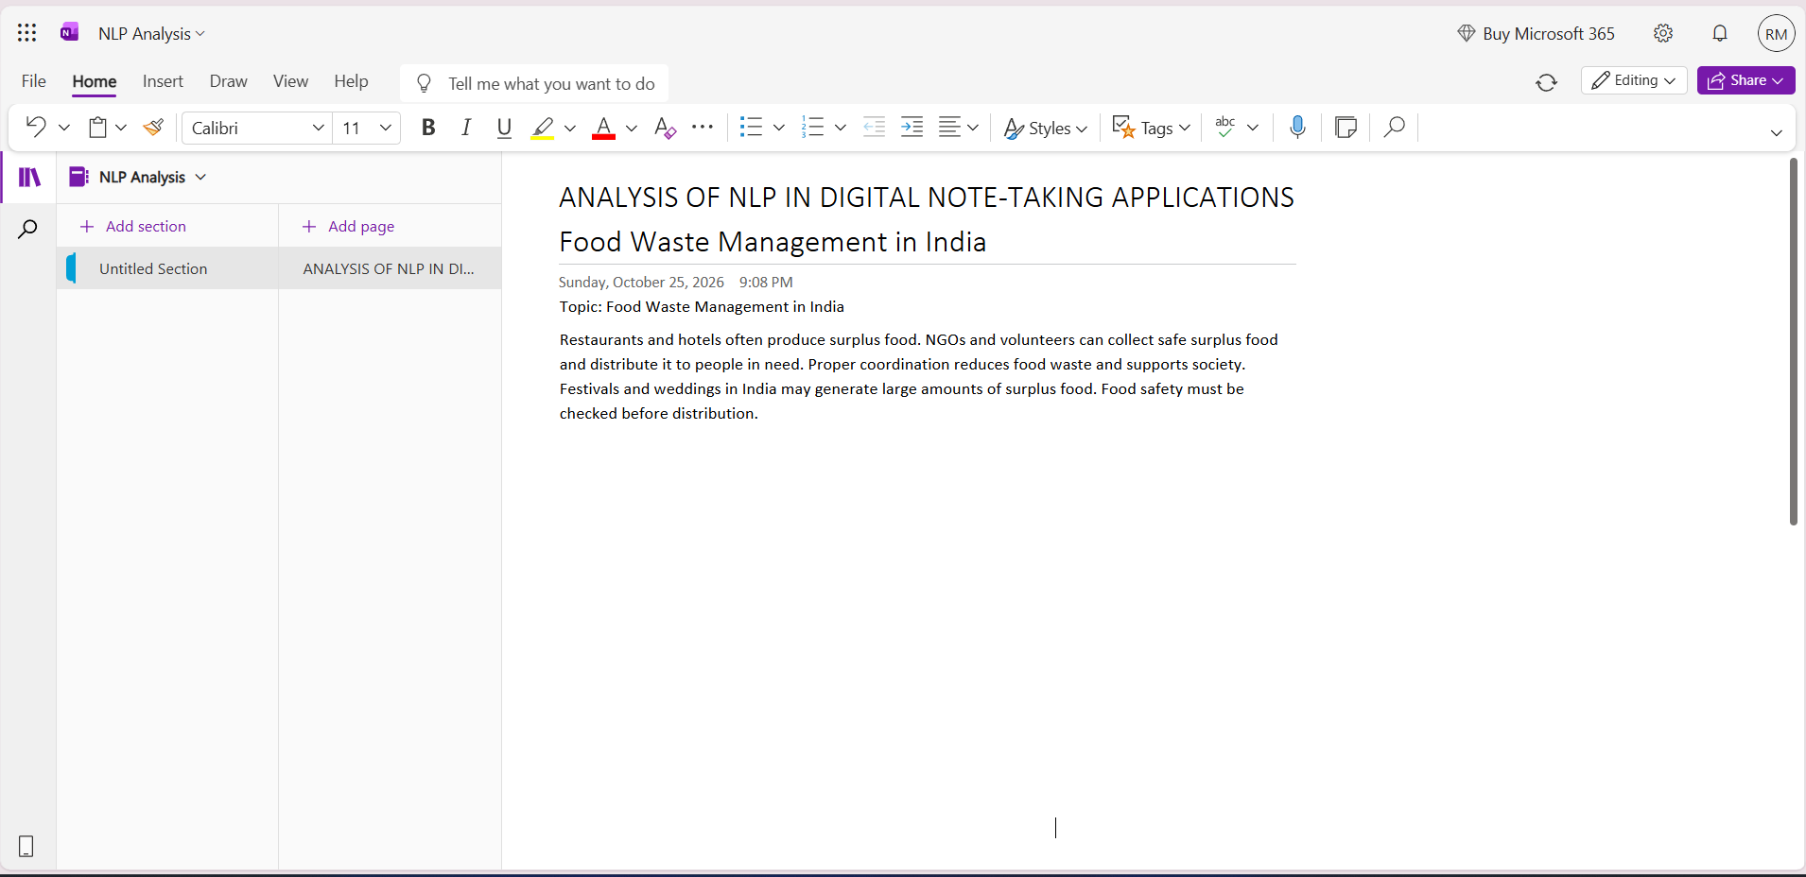
Figure 1. Microsoft OneNote page showing the English food-waste note.

Observed success
The text could be entered and displayed, and the note topic remained readable.

Observed limitation
AI summarization was not testable because Copilot was unavailable. No summary was invented or treated as an actual output.

4. Tool 2 — Evernote AI Assistant (CO1 i-b)
The same English sample was entered into Evernote. Its AI Assistant generated a proposed five-bullet summary. The visible output preserved the core ideas: surplus food from restaurants and hotels; collection and distribution by NGOs and volunteers; coordination to reduce waste; large amounts of food at festivals and weddings; and checking food safety before distribution. The interface showed proposed edits with Accept/Reject controls, so the output was reviewed as a suggestion.

4.1 English summarization output
- Restaurants and hotels often generate surplus food.
- NGOs and volunteers can collect safe surplus food and distribute it to people in need.
- Proper coordination reduces food waste while supporting society.
- Festivals and weddings can produce large quantities of surplus food.
- Food safety must be checked before distribution.
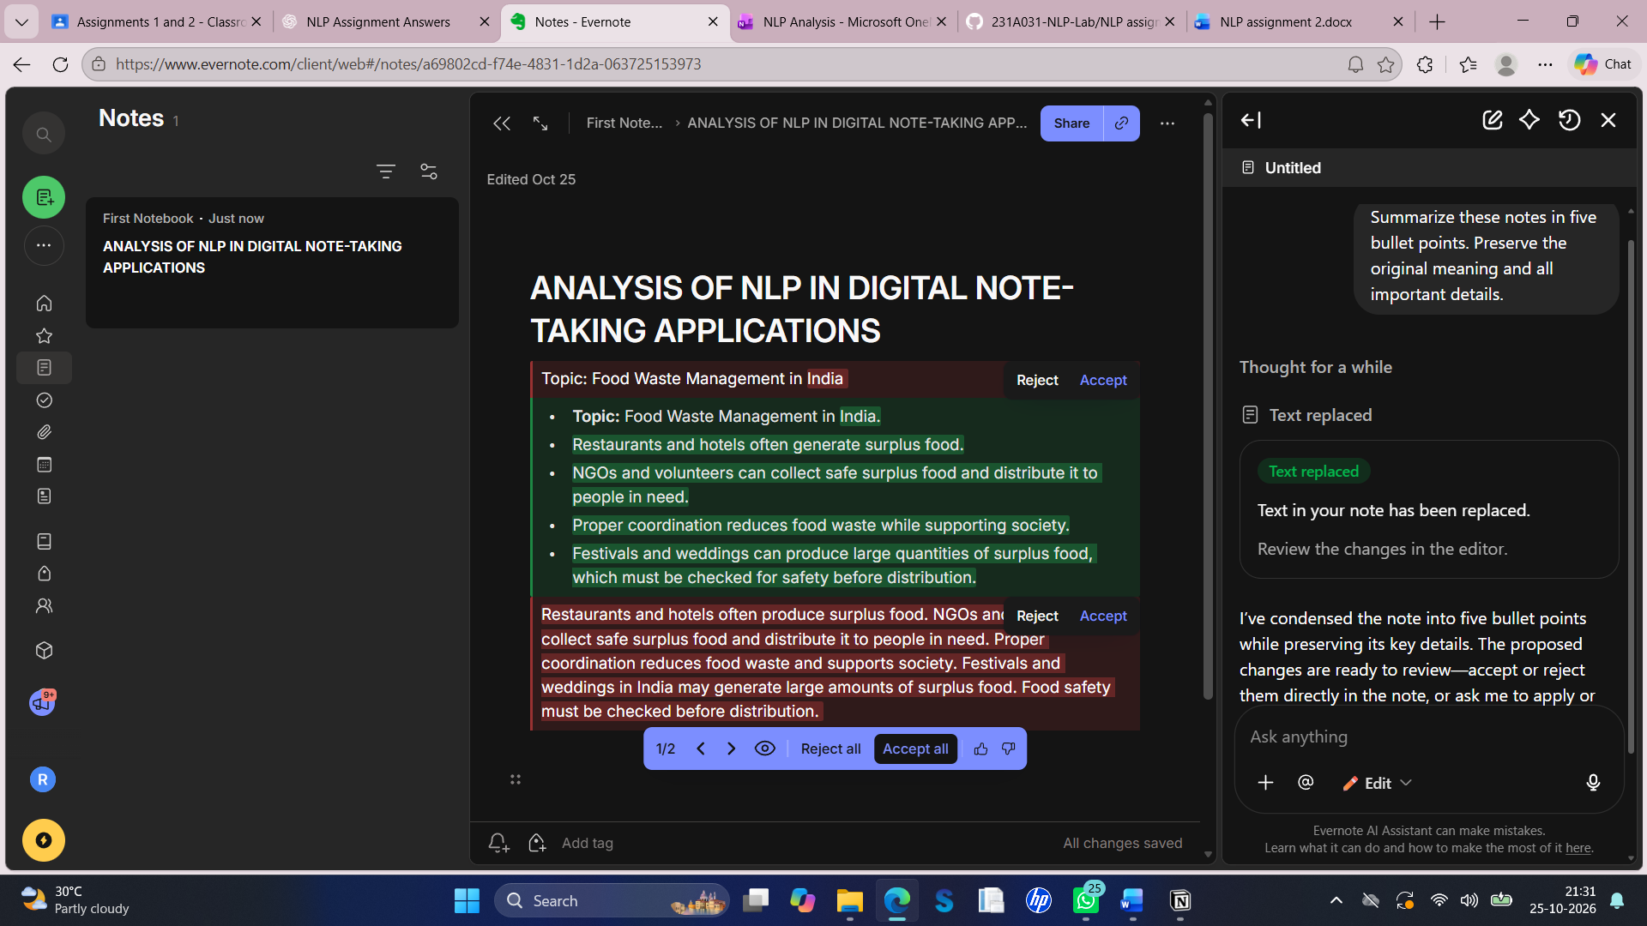
Figure 2. Evernote AI Assistant proposing a five-bullet English summary.
Evaluation: the summary is concise and retains the main information. No obvious major semantic error is visible in the captured output. The test is small and does not prove that the system is always accurate.

4.2 Hindi summarization output
Evernote AI Assistant also generated five bullet points for the Hindi input. The output stated that food is left over during festivals and weddings, the food can reach people in need, volunteers can collect and distribute it, NGOs can coordinate the process, and food quality and safety must be checked before distribution.
- भारत में त्योहारों और शादियों के दौरान बड़ी मात्रा में भोजन बच जाता है।
- इस बचे हुए भोजन को जरूरतमंद लोगों तक पहुँचाया जा सकता है।
- स्वयंसेवक भोजन एकत्र करने और वितरित करने में मदद कर सकते हैं।
- गैर-सरकारी संगठन इस प्रक्रिया के समन्वय में महत्वपूर्ण भूमिका निभा सकते हैं।
- वितरण से पहले भोजन की गुणवत्ता और सुरक्षा की जाँच करना आवश्यक है।
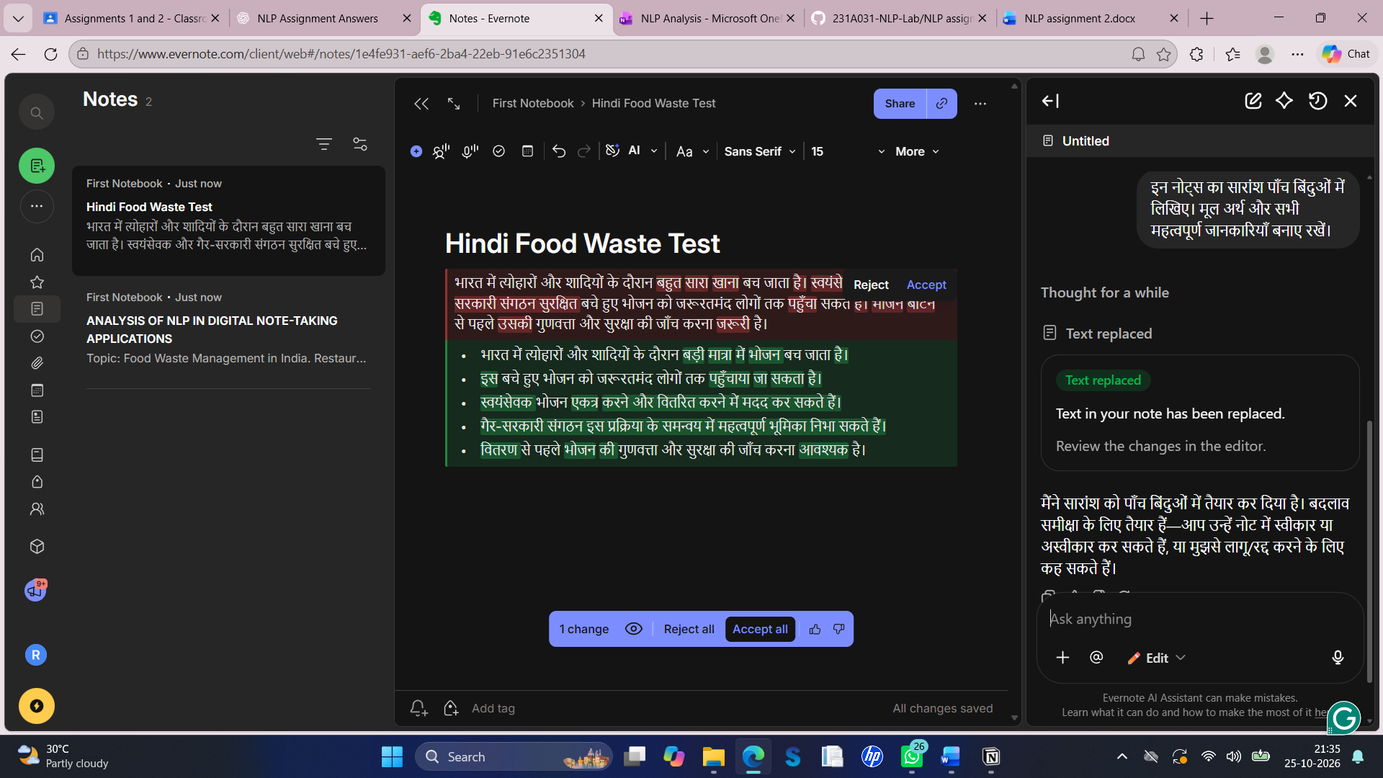
Figure 3. Evernote AI Assistant proposing a five-point Hindi summary.
Evaluation: the main meaning is preserved and the points are expressed in understandable Hindi. The test did not include multiple dialects, Romanized Hindi, or Hindi-English mixed sentences, so those capabilities remain untested.

4.3 Search test
The keyword “food safety” was entered into Evernote search. The results showed the English food-waste note and the separate Hindi Food Waste Test note. This demonstrates successful retrieval of notes associated with the search term. Because this test used a short keyword and the screenshot does not establish how the internal ranking works, it is described as keyword-based retrieval rather than conclusive proof of semantic search.
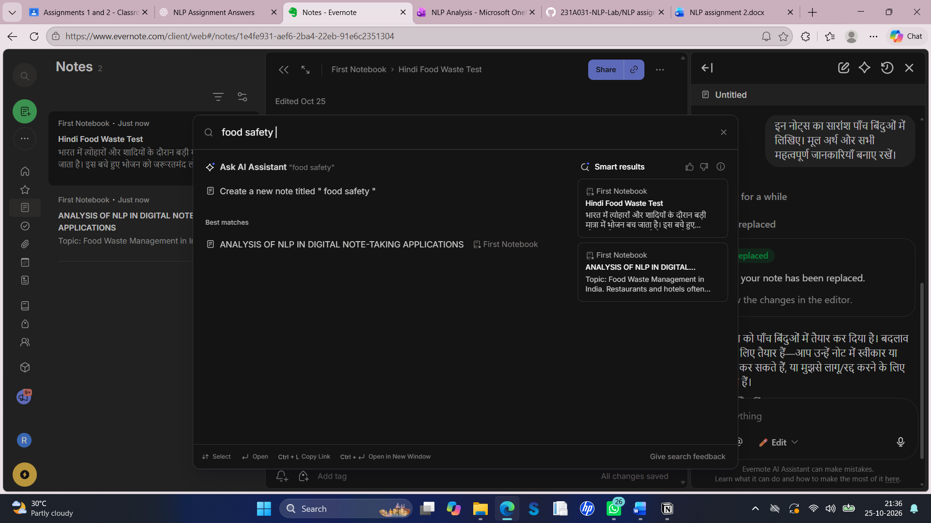
Figure 4. Evernote search for “food safety” displaying the English and Hindi notes.

5. Comparative Testing and Error Matrix (CO1 ii)
The same English text was used in OneNote and Evernote. Notion was also attempted as a supplementary tool, but Notion AI showed “Unavailable while offline”; therefore, no Notion AI output could be compared. The table distinguishes observed results from tests that could not be completed.
Criterion | Microsoft OneNote | Evernote AI Assistant | Notion (supplementary)
Same English input entered | Yes; text displayed | Yes; text displayed | Yes; text displayed
AI summary output | Not available; Copilot inaccessible | Five-bullet summary generated | Not available; AI said unavailable while offline
Main ideas preserved | Not assessable | Yes, in the visible output | Not assessable
Search test | Not evaluated as an AI feature | “food safety” returned both notes | Not evaluated
Hindi test | Not evaluated | Five-bullet Hindi summary generated | Not evaluated
Observed error type | Access/availability limitation | No obvious major meaning loss in sample | Access/offline limitation
Cultural context | Not assessable for AI output | Festivals and weddings retained | Not assessable for AI output

5.1 Error analysis
Error category | Evidence from this test | Finding
Grammatical error | English and Hindi summaries reviewed visually | No obvious major grammatical problem observed in the captured outputs; this is a small sample.
Semantic error / meaning change | Compared summaries with the original notes | Main claims were preserved; no obvious major meaning reversal observed.
Context loss | Festivals, weddings, volunteers, NGOs, and food safety checked | These key details remained in the summaries.
Translation error | Hindi input was summarized in Hindi, not translated | Translation accuracy was not tested; do not infer it from summarization.
Cultural/regional misunderstanding | Indian festivals and weddings were mentioned | The AI retained these references. Regional dialects and other cultural practices were not tested.
Tool availability failure | Copilot unavailable; Notion AI unavailable offline | This prevented output comparison for those tools; it is not an NLP language error.

Important limitation: this is a qualitative test on one short topic, not a statistically representative benchmark. Since OneNote and Notion did not provide AI summaries under the available conditions, their summary accuracy and error rates cannot be scored fairly.

5.2 Supplementary Evidence - Notion Note Entry
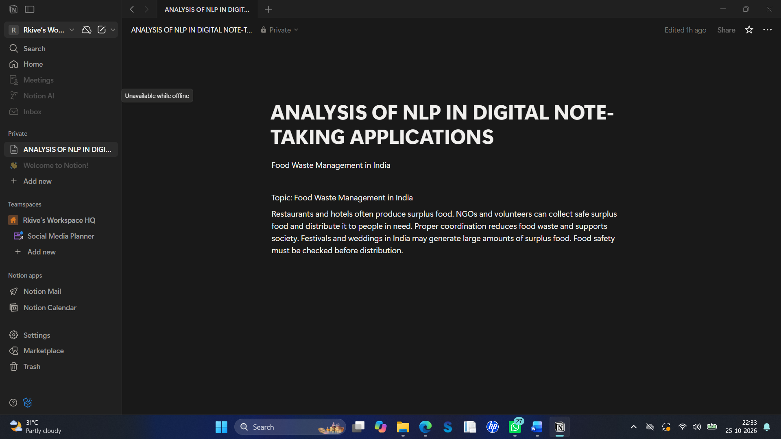
Figure 5: Notion page showing the English food-waste note entered successfully

The same English text on “Food Waste Management in India” was entered into Notion. As shown in Figure 5, Notion successfully displayed the title and the complete paragraph about surplus food, NGOs, volunteers, Indian festivals and weddings, and food safety.
However, during the AI test, Notion AI displayed the message “Unavailable while offline.” Therefore, an AI-generated summary could not be obtained from Notion. The note-entry function worked successfully, but its AI summarization accuracy could not be evaluated in this test.
Observation: Notion successfully stored and displayed the English input. The limitation was the unavailability of its AI feature, not a confirmed grammatical or semantic error.

6. Successes and Limitations (CO1 i-c)

Successes
- Evernote condensed the English paragraph into five readable bullet points.
- The English summary preserved the main facts and the food-safety requirement.
- Evernote generated a Hindi summary that retained the key ideas from the Hindi input.
- The search for “food safety” displayed both the English and Hindi notes, showing useful retrieval in this small test.
- The cultural references to Indian festivals and weddings were retained rather than omitted.

Limitations
- OneNote AI summarization could not be tested because Copilot was unavailable in the account.
- Notion AI could not be tested because the interface showed “Unavailable while offline.”
- Evernote’s search test used a keyword; it does not prove that every natural-language or semantic query will work.
- Only one short English and one short Hindi sample were tested. Dialect, Romanized Hindi, code-switching, spelling variation, and longer notes were not tested.
- The generated summary was a proposed edit requiring review. AI output should be checked before relying on it, especially for food safety.

7. Adapting Digital Note-Taking for Hindi (CO1 iii)
Hindi is a useful target language because it is widely used in India and often appears in digital notes together with English. A Hindi-enabled note-taking tool should support both Devanagari Hindi and the mixed-language style used in everyday typing.

7.1 Required linguistic resources
Resource | Purpose in a Hindi note-taking system
Hindi text corpora | Provide varied examples of formal Hindi, conversational Hindi, educational notes, and everyday writing.
Hindi POS tagger and morphological analyser | Identify nouns, verbs, adjectives, postpositions, inflections, and sentence structure.
Hindi tokenization and sentence segmentation | Split text reliably while handling punctuation, joined characters, and Devanagari marks.
Hindi language models / multilingual language models | Support summarization, question answering, and note retrieval in Hindi.
Hindi-English parallel and code-switched datasets | Train and evaluate mixed sentences such as “Meeting ke notes save kar do.”
Named-entity recognition resources | Recognize names of people, NGOs, locations, festivals, dates, and organizations.
Human-annotated evaluation sets | Measure summary faithfulness, important-detail coverage, grammar, and retrieval quality with native speakers.

7.2 Concrete adaptation steps
- Collect consented Hindi notes from different regions and domains; remove personal or confidential information before using them for training.
- Normalize Unicode and handle Devanagari matras, nukta characters, punctuation, spelling variants, and sentence boundaries without changing the user's intended meaning.
- Fine-tune or adapt a Hindi-capable language model for summarization and note retrieval using high-quality Hindi examples.
- Add POS tagging, morphological analysis, named-entity recognition, and sentence segmentation to improve identification of important information.
- Train on code-switched Hindi-English examples and support Romanized Hindi as well as Devanagari.
- Create a test set containing formal Hindi, conversational Hindi, regional vocabulary, Romanized Hindi, and cultural topics.
- Evaluate outputs with native Hindi speakers for factual faithfulness, grammar, omitted details, and cultural appropriateness; allow users to correct summaries.

7.3 Sociolinguistic challenges
Challenge | Example | Suggested response
Code-switching | “Meeting ke notes save kar do.” | Train on Hindi-English mixed text and avoid treating English words as noise.
Script variation | “कल meeting hai” versus “कल मीटिंग है” | Support Devanagari and Romanized Hindi; preserve original script when possible.
Dialect and regional vocabulary | Different regional words for the same object or activity | Include regionally diverse examples and evaluate with speakers from different regions.
Informal spelling and abbreviations | Short forms, missing matras, phonetic typing | Use robust normalization and allow the user to keep or undo corrections.
Cultural context | Festivals, weddings, community meals, food donation | Include Indian cultural examples and preserve context instead of making unsupported assumptions.
Gender, number and agreement | Hindi verbs/adjectives change with grammatical context | Use morphology-aware processing and evaluate agreement and sentence naturalness.

8. Conclusion
This assignment tested digital note-taking using Microsoft OneNote and Evernote, with Notion noted as a supplementary attempt. OneNote successfully displayed the English sample, but Copilot was unavailable. Notion AI was unavailable while offline. Evernote AI Assistant generated five-bullet summaries for both English and Hindi inputs, and the captured outputs retained the main ideas about surplus food, volunteers, NGOs, Indian festivals and weddings, and food safety. A search for “food safety” displayed the English and Hindi notes. The results are encouraging but limited to a small qualitative sample. Better Hindi support requires diverse corpora, POS tagging and morphological tools, Hindi-capable language models, code-switching data, script normalization, and evaluation across dialects and cultural contexts.

9. References
- Microsoft OneNote. https://www.onenote.com/
- Microsoft Support. Frequently asked questions about Copilot in OneNote. https://support.microsoft.com/en-us/onenote/frequently-asked-questions-about-copilot-in-onenote
- Notion. https://www.notion.so/
- Notion Help Centre. Notion AI FAQs. https://www.notion.com/help/notion-ai-faqs
- Evernote Help Centre. Evernote AI Assistant. https://help.evernote.com/hc/en-us/articles/46319409880211-AI-Assistant
- Evernote Help Centre. Evernote AI Features Overview. https://help.evernote.com/hc/en-us/articles/46594411188371-Evernote-s-AI-Features-Overview

Appendix: Evidence and interpretation
Figures 1–4 are screenshots supplied by the student from the actual applications. Figure 1 records the OneNote note. Figures 2 and 3 show Evernote's proposed English and Hindi summaries; Figure 4 shows the keyword search results. The report does not claim that OneNote or Notion generated AI outputs when those outputs were unavailable. The Hindi screenshot shows proposed changes; it should be understood as a proposed output unless the Accept action was completed.

